I would like to begin with the webpage; the Hashemite university ([www.hu.edu.jo](http://www.hu.edu.jo)) has a link with the project logo implemented in the main university website (please see enclosed). Our local website: [http://meditec.just.edu.jo](http://meditec.just.edu.jo/) for workshops, info days, internal presentations, etc. to be added.

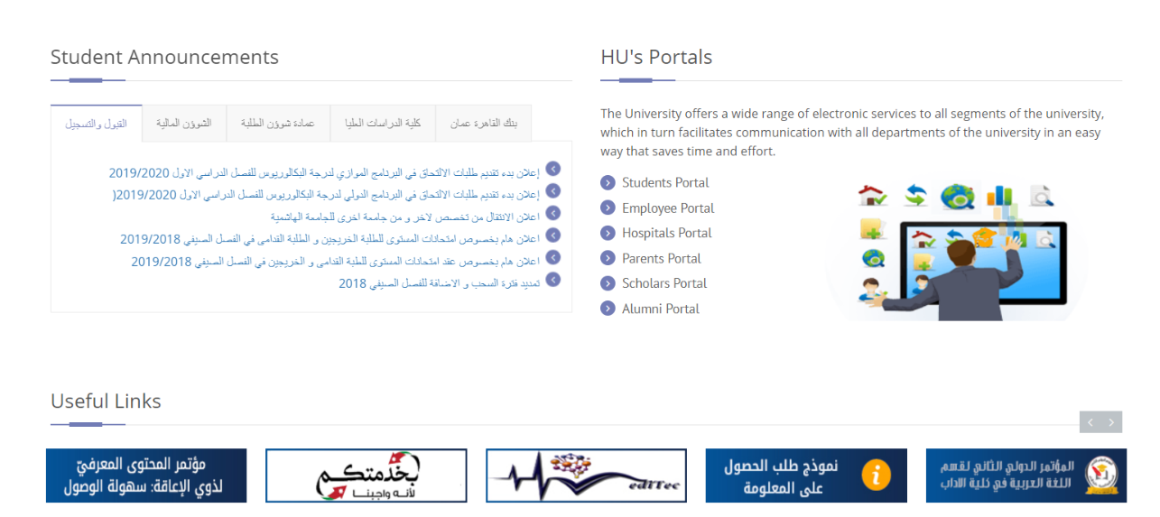

**Project timeline**

**Date: October 2017**

**Activity:** Info day to staff and students about the project

**Performers:** Professor Ahmad Khasawneh, Professor Darwish Badran, Dr. Aiman Al Sharei

**Objectives:** During this day, the project main ideas, objectives and anticipated activities were presented to staff and to the newly admitted medical students at Hashemite University during the annual meeting.

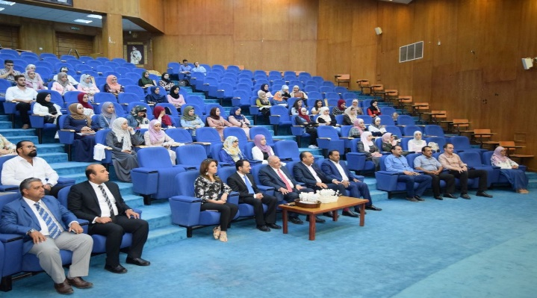

**Date: November 2017**

**Activity:** Internal presentation for students about the project at Hashemite University, brainstorming medical educational tools

**Performers:** Professor Darwish Badran, Professor Ahmad Khasawneh, Dr. Aiman Al Sharei

A meeting with medical staff and students to identify the technology and tools required to develop medical education at Hashemite University.

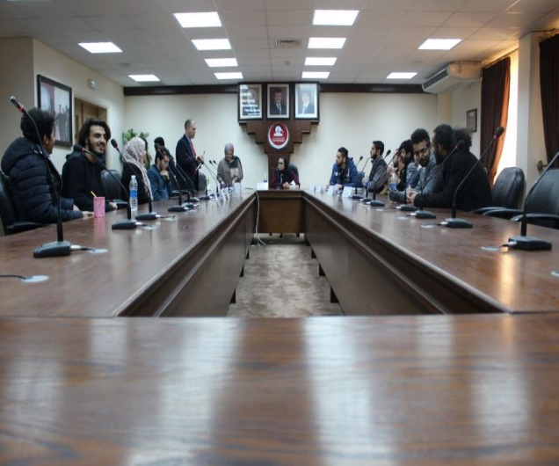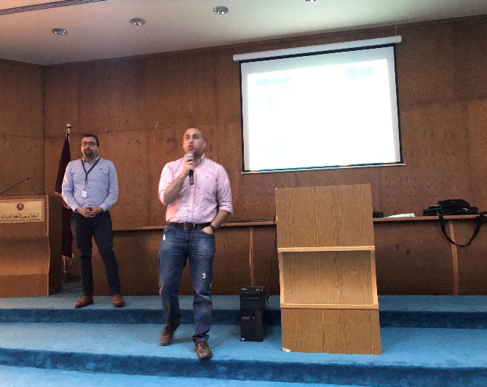

**Date: February 2018**

**Activity:** Presenting the milestones achieved by Hashemite University at the kickoff meeting at the dead sea, Jordan.

**Performers:** Professor Ahmad Khasawneh, Dr. Aiman Al Sharei, Dr. Bashar Hammad

**Objectives:** Power point slides were presented through the kickoff meeting with all MediTec members in the Dead Sea, Jordan, showing the milestones and achievements made in the adoption of technology in medical education at Hashemite University.

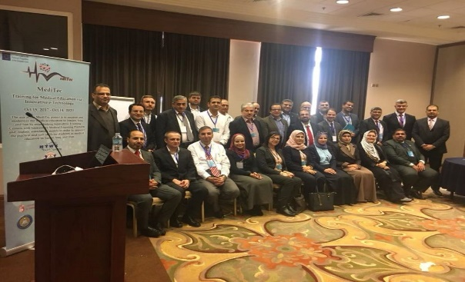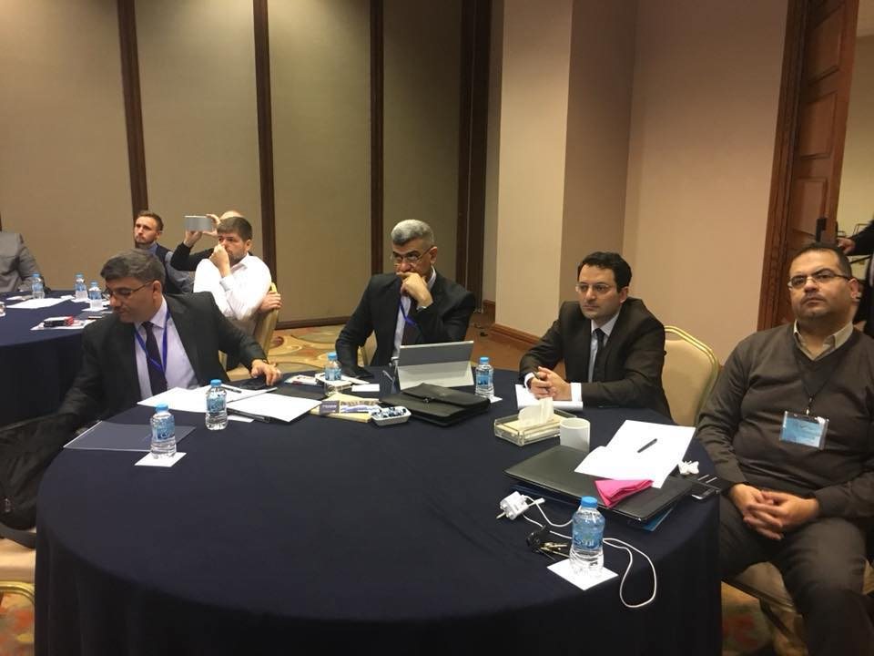

**Date: February 2018**

**Activity:** Introducing the project and the experiences of Hashemite University in its adoption of technology in medical education

**Performers:** Professor Darwish Badran, Professor Ahmad Khasawneh, Dr. Aiman Al Sharei

**Objectives:** PowerPoint slides were presented to students and staff reflecting the project goals and objectives to transfer the knowledge and the experiences of Hashemite University in medical education, and revealing new means of medical education disseminated at the dead sea kickoff meeting through project partners.

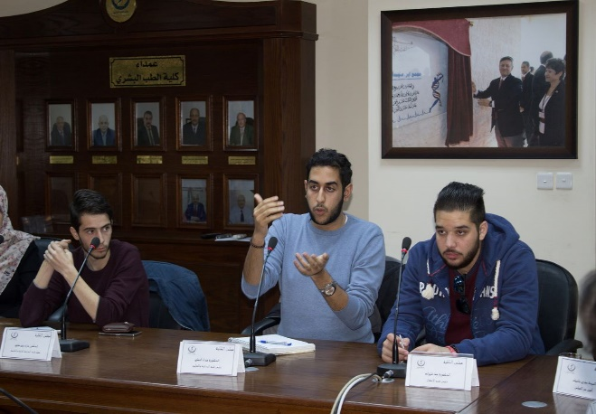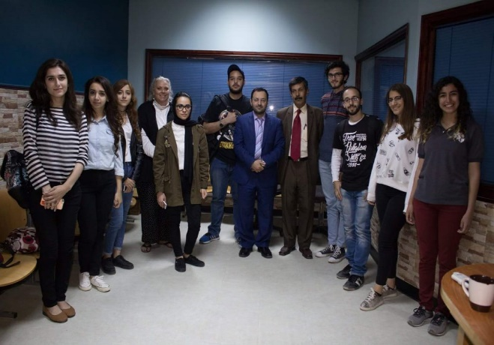

**Date: May 2018**

**Activity:** Brainstorming of the Anatomy course curriculum

**Performers:** Prof. Darwish Badran, Dr. Aiman Al Sharei, Prof. Ashraf Ramzi, Dr. Mustafa Saad

**Objectives:** A meeting with the anatomists and students from the medical faculty at Hashemite University to decide what is needed to be incorporated in the projected 3D anatomy course to fit in the context of the project.

**Date: July 2018**

**Activity:** Follow up meeting to discuss the main frame of the suggested plan to create incorporate technology in the Anatomy course curriculum

**Performers:** Prof. Darwish Badran, Dr. Aiman Al Sharei, Prof. Ashraf Ramzi, Dr. Mustafa Saad

**Objectives:** Two meetings with medical staff and students were held to discuss the main frame of the newly designed template in scope to create a 3D-Anatomy course.

**Date: November 2018**

**Activity:** Staff training in Slovakia

**Performers:** Prof. Darwish Badran, Dr. Aiman Al Sharei, Prof. Ahmad Khasawneh

A training pogram was attended provided by Pavol Jozef Šafárik University in Košice, Slovakia.

**Objectives:** The training was realized in the form of conferences with trainings to share theoretical and methodological experiences in modernization of medical education, multiple visits and workshops were held at Pavol Jozef Šafárik University campus, venues and hospitals.

Highlighted activities:

1. Identifying the Strengths, Weaknesses, Opportunities & Threats of the existing training programs, including academic and non-academic staff skills.

2. Introducing and modernization of the training curriculum, teaching material and exam methods as base to improve training program in Health Sciences.

3. Discussing with the partners, Cardiovascular Prevention, Anatomy, Nursing Care, Public Health and Hygiene, Medical Physiology, Biophysics in Medicine, Experimental Medicine, Resistance to antibiotics, Biomedical engineering, Radiology and Nuclear Medicine, and Medical Informatics at UPJS. As well as discussion on First Aid in Health Care Disciplines, Neonatology, Simulations in Gynecology and Obstetrics and Simulations in Surgery

Visits were to following places:

- Department of Medical and Clinical Biophysics

- Department of Experimental Medicine

- Department of Medical Physiology

- Department of Nursing Care

- Department of Anatomy

- Department of Biomedical Engineering and Measurement

- Department of Anesthesiology and Intensive Medicine

- 1st Department of Surgery

- Department of Gynecology and Obstetrics

- Department of Neonatology

- East Slovak Institute of Cardiovascular Diseases-

- Department of Stomatology and Maxillofacial Surgery at Akadémia Košice,

- Forensic Medicine and Health Care Supervision at UPJS.

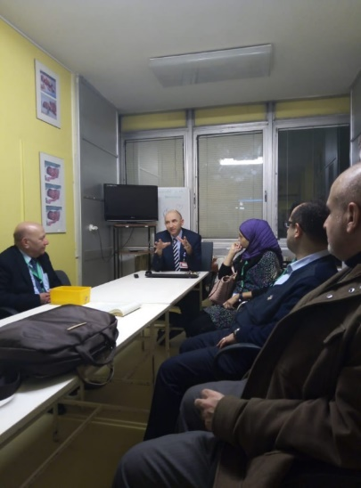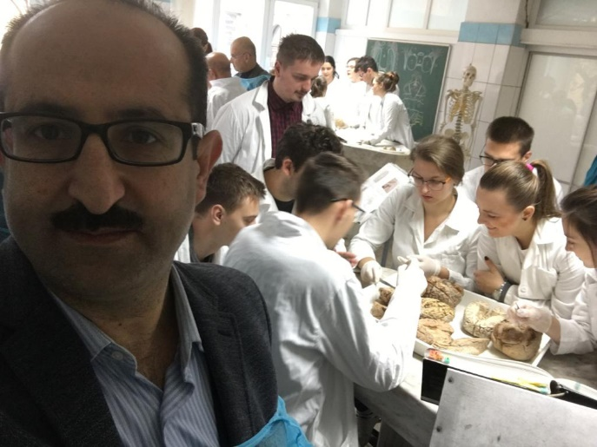

**Date: January 2019**

**Activity:** Transferring knowledge and skills from the training in Slovakia

**Performers:** Prof. Darwish Badran, Dr. Aiman Al Sharei

Faculty meetings took place to discuss the deliverables received through the training in Slovakia. Students’ feedback about the learning outcome was in consideration.

**Objectives:** To share theoretical and methodological experiences in modernization of medical education through the multiple visits and workshops attended at Pavol Jozef Šafárik University campus, venues and hospitals.

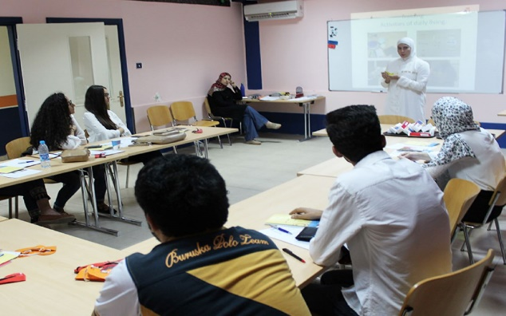

**Date: January 2019**

**Activity:** Staff training in Czech Republic

**Performers:** Dr Muhannad Odeh

A training program was attended provided by Masaryk University, Brno, Czech Republic.

**Objectives:** The training was realized in the form of conferences with trainings to share theoretical and methodological experiences in modernization of medical education, multiple visits and workshops were held at Masaryk University campus, venues and St. Anne’s hospital.

Highlighted activities:

1. Identifying the Strengths, Weaknesses, Opportunities & Threats of the existing training programs, including academic and non-academic staff skills

2. Introducing and modernization of the training curriculum, teaching material and exam methods as base to improve training program in Health Sciences

Lectures and workshops discussed the following:

A) Current healthcare issues in Europe and approach to their management

B) Quality management in health care institutions

C) Health / Healthcare education and promotion

Visits were to the following centers:

A) Department of Biophysics

B) Center for HC quality #

C) Department of Anatomy

D) Department of Radiology and Nuclear Medicine

E) St. Anne´s University Hospital

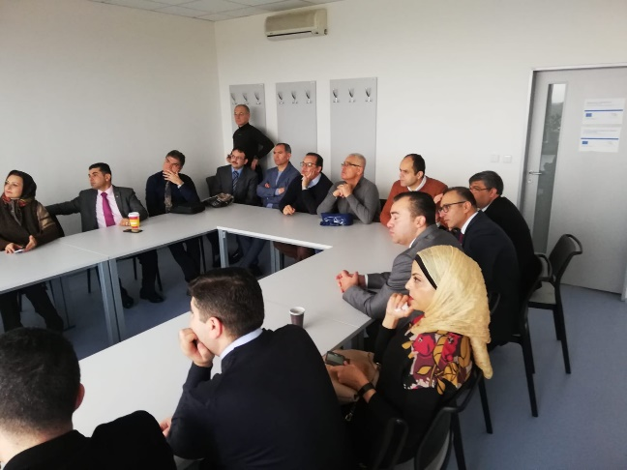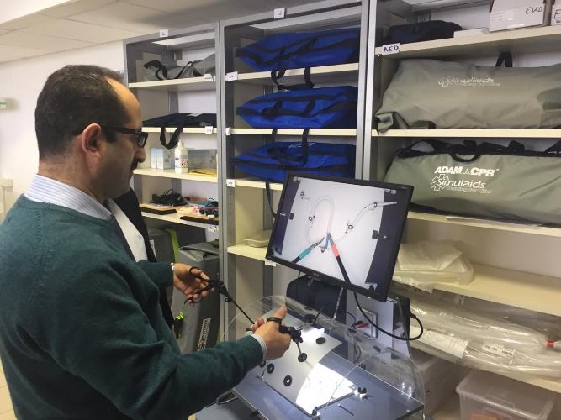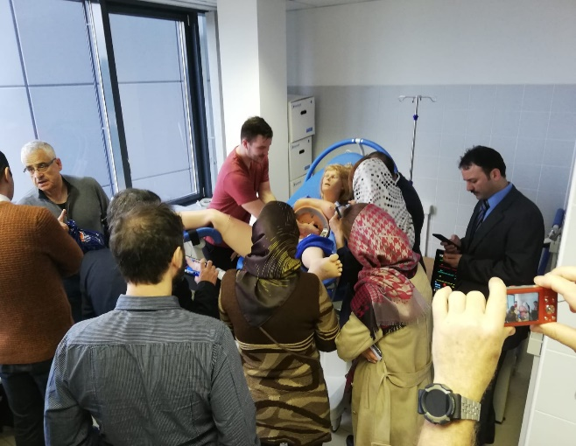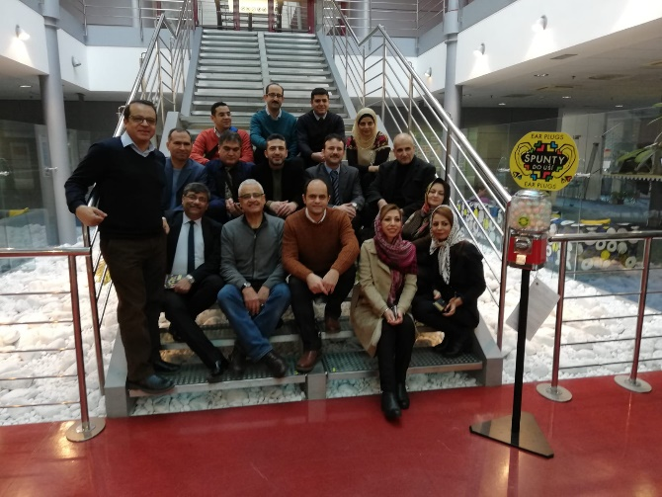

**Date: May 2019**

**Activity:** Installation of equipment and engaging students

**Performers:** Dr Aiman Al Sharei Professor Ahmad Khasawneh,

The installation of Zspace and human anatomy models and other equipment took place at the faculty of medicine at Hashemite University. A dedicated laboratory was assigned for this purpose.

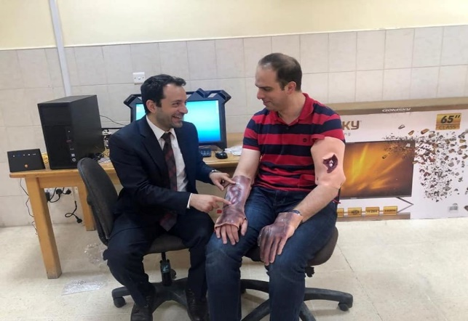 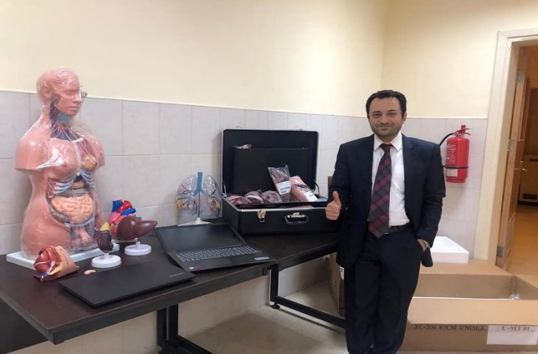

**Date: June 2019**

**Activity:** Staff training in Malta University

**Performers:** Professor Darwish Badran, Dr Haytham Hayajenh

A training program was attended provided by Malta University, Msida, Malta.

**Objectives:** Sharing theoretical and methodological experiences in modernization of medical education, multiple visits and workshops were held at Malta University campus, medical faculty and its departments and labs, in addition to the university hospital, faculty of IT and training in the simulation lab.

**Highlighted activities:**

1. Identifying the Strengths, Weaknesses, Opportunities & Threats of the existing training programs, including academic and non-academic staff skills

2. Introducing and modernization of the training curriculum, teaching material and exam methods as base to improve training program in Health Sciences

3. Training in academic assessment including Multiple Choice Exams, OSCE, in addition to discussions and various seminars covering medical insurance and many more.

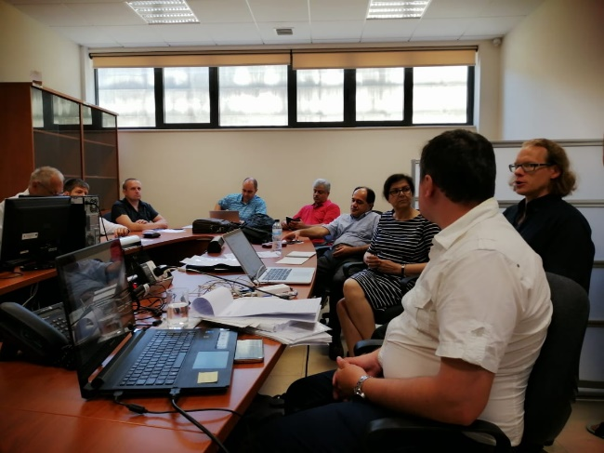 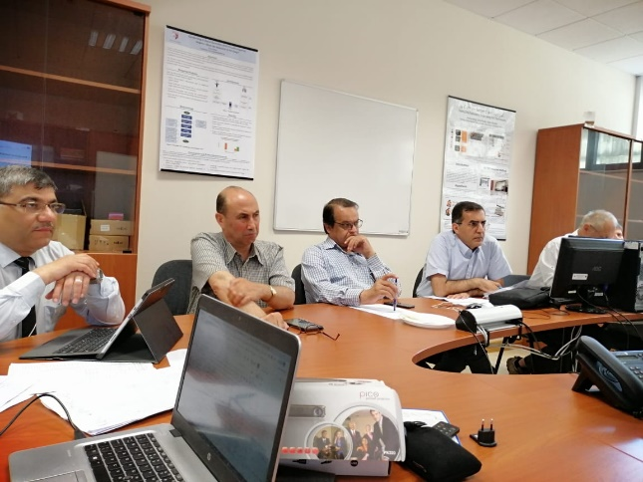

**Date: August 2019**

**Activity:** Info day and internal presentation to medical students

**Performers:** Dr Aiman Al Sharei

The faculty of medicine presented what’s new and innovative in medical education using 3D visualized anatomy application and devices. An info day and internal presentation to medical students was hosted in the Digital Anatomy Lab and in the newly established Center for Innovative Training in Medical Education, a project funded by Erasmus+.

**Objectives:** To familiarize students with the current means of incorporating technology with medical education, students were introduced to the project and its goals. To make students experience by themselves the newly installed 3D Anatomy software and hardware and to be encouraged to utilize it at larger scale, in addition to incorporating them in the process of reshaping the pedagogical methods in delivering anatomy knowledge.

